Graham Smith

Graham@gmail.com

Abstract

Optimised scanning of picked stock items to verify picker accuracy implementation plan – phase 1

Phase 1 implementation plan – outbound scan check

**Table of Contents**

1. Overview 2

2. Desired layout 2

3. Risks and potential issues 3

4. Use supplier item barcode strategy internally 3

5. Infrastructure costing 3

6. Phase 1 development investment schedule 4

# Overview

Subject to the contents of document ***ScopeScanCheck v3.doc***, the intent of this document is to provide the following:

* 1. Desired physical layout on one lane only
  2. Placement of equipment
  3. Defined functional implementation
  4. Cost for phase 1 implementation

The proposal herewith is limited to the current understanding of requirement. It is anticipated that post implementation there will be changed requirements that could influence the delivered functionality; thus this proposal is considered the 1st phase proposakl.

# Desired layout

As per the scoping document, there is a proposed operating method that is considered a close match to that of a supermarket check-out process.

As part of the governance around changing the layout of the despatching lanes, it is propped that:

* 1. Only one lane is equipped and tested to gain insight and experience of what might work better before making changes to all the other lanes
  2. To have a little disruption as possible, the current equipment and method of operation is retained
  3. The plan is to have Point of Sale stationary scanners, but it is proposed that wired USB scanners be used until the rollout confirms a confirmed need and then changed to have improved scanning functionality
  4. 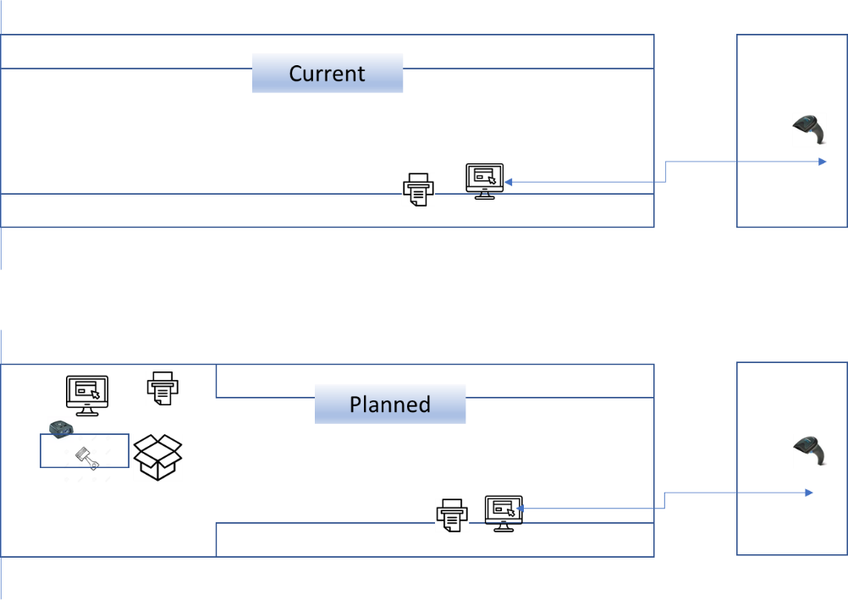The following diagram provides a view of how the floor space at despatch should be changed to accommodate the planned for layout.

# Risks and potential issues

The main risk component is the function of barcode scanning where the following issues may be encountered during rollout:

* 1. Items do not have a barcode due to size and / or ePart does not print barcode labels for some (consumer) type items
  2. Barcode cannot be scanned – poor quality

# Use supplier item barcode strategy internally

It has been recognised that over time suppliers have been more diligent in printing barcodes on their packaging material. There is a scoping document available that reflects on how this should be deployed into ePart end to end.

Should the functionality of the 1st phase be in line with expectation but the quality of the barcode on the items detract from the expected performance, then the end to end solution should be considered for active implementation.

# Infrastructure costing

As per the proposed layout changes and retention of current (IT) infrastructure, the following schedule summarises the costs elements and assumed investment for the 1st despatching lane:

|  |  |  |  |  |
| --- | --- | --- | --- | --- |
| **#** | **Description** | **Units** | **Cost** | **Total** |
| 1 | Shorten conveyor rollers | 1 | 1,000 | 1,000 |
| 2 | Power point | 1 | 1,000 | 1,000 |
| 3 | Network point | 1 | 750 | 750 |
| 4 | Work table | 1 | 1,200 | 1,200 |
| 5 | New PC | 1 | 4,500 | 4,500 |
| 6 | Large PC display screen | 1 | 2,500 | 2,500 |
| 6 | Temporary cabled barcode scanner | 1 | 0 | 0 |
| 7 | Mount PC screen | 1 | 450 | 450 |
| 8 | Extended PC screen cable | 1 | 100 | 100 |
| 9 | Install equipment & test | 1 | 1,500 | 1,500 |
| **Total** | | | | **13,000** |

Subject to the opportunity to re-deploy current equipment, the infrastructure cost could be reduced for the other despatching lanes.

However, it is proposed that new equipment be installed, especially the PC display units that should be larger than the standard size for the new style checking process can create better visibility of the process.

# Phase 1 development investment schedule

The enclosed schedule provides an investment estimate to produce a 1st phase deployment of the stated objective as detailed in the scoping document.

It is the authors opinion that the investment schedule reflects best effort to define all the perceived costs. Should the implementation require a changed scope, this will be communicated in writing with appropriate justification.

Historically, ePart development for user interfaces (data input and viewing) was / is accomplished using a now unsupported toolset Borland C++ Builder. After some research, it was established that the Microsoft C# development platform can be integrated into the current format of ePart deployment. However, some of the ***standard*** ePart functions need to be re-created and may contribute to some increased investment requirements.

The schedule provided reflects an investment amount irrespective of who performs the development and implementation and is costed out at a standardised hourly rate. It is anticipated that Jaco can be participant in the development process. However, this may be limited due to his current workload. Nearer the time, the tasks will be clearly defined in a time-line manner and then parcelled out according to time and resource.

Should the author be participant this will incur expenditure that may need justification with senior management. Enclosed in the scoping document, is a detailed analysis of benefits etc. that can be used to justify the necessary expenditure. However, the author, if to be participant, can schedule his participation such that it will reduce the expenditure impact.

The following schedule reflects the authors best effort to define all the possible areas of investment:

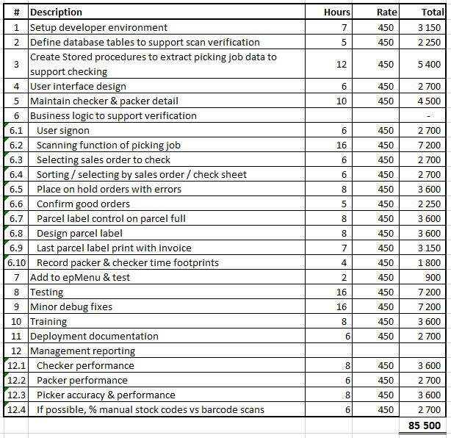

* Amounts are quoted VAT exclusive
* Pricing is fixed for 15 calendar days
* Additional functionality will change the proposed investment amounts.
* Additional lane rollout not quoted for herewith